FPGA Implementation of K-Means Clustering for RGB Video Streams

Overview
This section presents the implementation of k-means RGB clustering on Field Programmable Gate Arrays (FPGAs), specifically designed for processing video streams. The solution is built around a standard Xilinx AXI4 streaming interface, which facilitates seamless integration into existing image processing pipelines. The primary objective is to accelerate image segmentation tasks by leveraging the parallel processing capabilities inherent to FPGA devices.

Design Approach
The module utilizes parallel processing techniques to enhance the speed and efficiency of both cluster assignment and centroid update operations, which are fundamental steps in the k-means clustering algorithm. By optimizing resource usage and minimizing latency, the design takes full advantage of the hardware-specific features available on Xilinx FPGA platforms.

Integration and Compatibility
To ensure broad compatibility and straightforward integration, the k-means clustering module is equipped with a standard Xilinx AXI4 streaming interface. This enables the module to function as an IP core within a variety of image processing workflows, allowing it to be inserted directly into any pipeline that supports AXI4 streaming.

Efficient RGB Stream Segmentation
Through the use of k-means clustering, the module segments incoming RGB video streams efficiently. The design’s hardware optimizations ensure that the clustering process is both fast and resource-conscious, making it well-suited for real-time image segmentation tasks on FPGA devices.
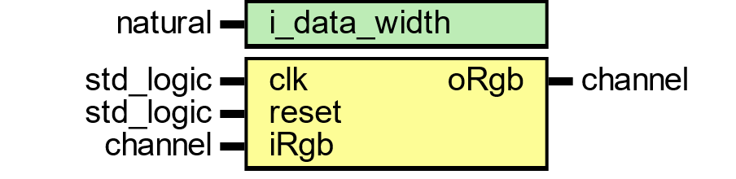
Figure 145 – K-Means Clustering VHDL Module Interface
This figure illustrates the VHDL entity-level interface of the k-means clustering module used for RGB video stream segmentation on FPGA. The module is parameterized by i_data_width, which specifies the bit width of the input pixel data, enabling configurability for different resolutions and precision levels.
- clk: The system clock input that synchronizes all operations within the module.
- reset: An asynchronous reset input that initializes or clears the module state.
- iRgb: The input RGB pixel stream, provided in parallel channels (red, green, blue) with associated control signals for frame, line, and pixel validity.
- oRgb: The output RGB pixel stream, where each pixel has been clustered into its assigned centroid color in the RGB space.
This VHDL interface reflects a modular, reusable design that can be instantiated as an IP core within larger video pipelines, seamlessly connected to other AXI4-Stream–based modules in a hardware image processing flow.

Module Data Flow and Interface
The k-means clustering module is designed to process a continuous stream of camera data formatted in a pixel pipeline structure. This incoming data stream is provided to the module through dedicated input channels corresponding to each RGB component: iRgb.red, iRgb.green, and iRgb.blue. In addition to the color channels, several control signals are required to manage the flow and validity of the data:
- iRgb.valid: Indicates when the input pixel data is valid and ready for processing.
- iRgb.eol: Marks the end of a line within the video stream.
- iRgb.eof: Signals the end of a frame.
- iRgb.sof: Denotes the start of a new frame.
Once the data has been processed through the k-means clustering algorithm, the resulting RGB cluster color space is output via the oRgb channel. This output represents the segmented version of the input stream, with each pixel assigned to its respective cluster in the RGB color space.
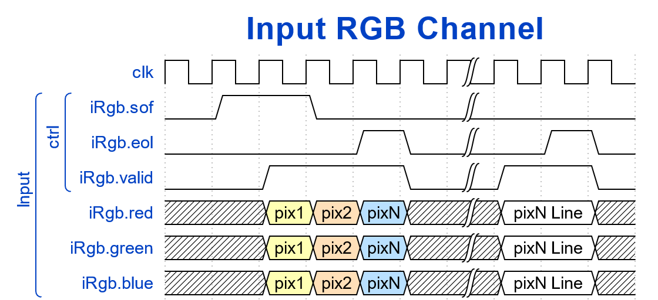
Figure 146
Figure 146 – Input RGB Channel Interface
This diagram illustrates the structure of the input RGB video stream to the FPGA-based k-means clustering module. The stream is delivered through three parallel channels: iRgb.red, iRgb.green, and iRgb.blue, each carrying pixel data for one color component. Control signals, including iRgb.sof (start of frame), iRgb.eof (end of frame), iRgb.eol (end of line), and iRgb.valid (data valid), ensure correct synchronization of pixels across frames and lines. Each pixel (pix1 to pixN) is aligned across the three channels, forming complete RGB pixels that feed directly into the clustering engine.
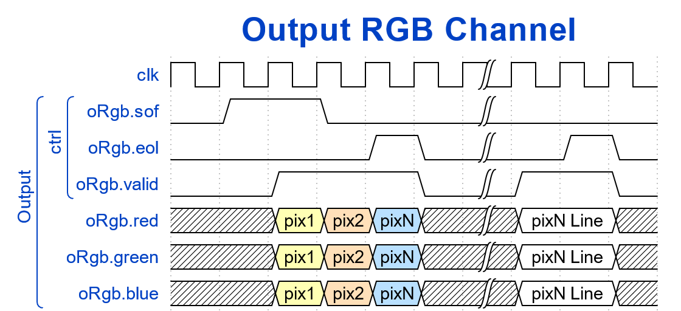
Figure 147
Figure 147 – Output RGB Channel Interface
This diagram shows the output RGB stream after processing by the FPGA’s k-means clustering module. The output channels (oRgb.red, oRgb.green, oRgb.blue) carry the cluster-assigned color values, effectively segmenting the video frame into clusters in RGB color space. Similar control signals (oRgb.sof, oRgb.eof, oRgb.eol, oRgb.valid) mark frame boundaries, line terminations, and pixel validity, preserving synchronization with the input stream. The result is a continuous, frame-by-frame clustered RGB stream suitable for real-time display or further processing in downstream video pipelines.

